Build A Mobile App

|  |  |
| --- | --- |
| Team ID | PNT2022TMID45278 |
| Project Name | Real-time river water quality monitoring and control system |

Configure The Mobile App For Controlling Motor Using Buttons

Node – RED configuration:

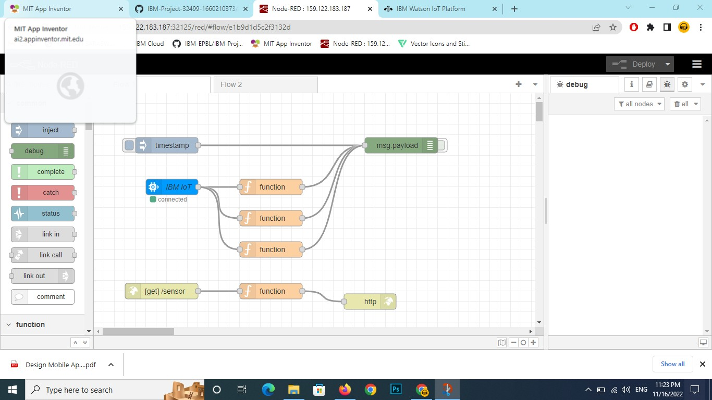

Intial stage

Collected datas shown in figure

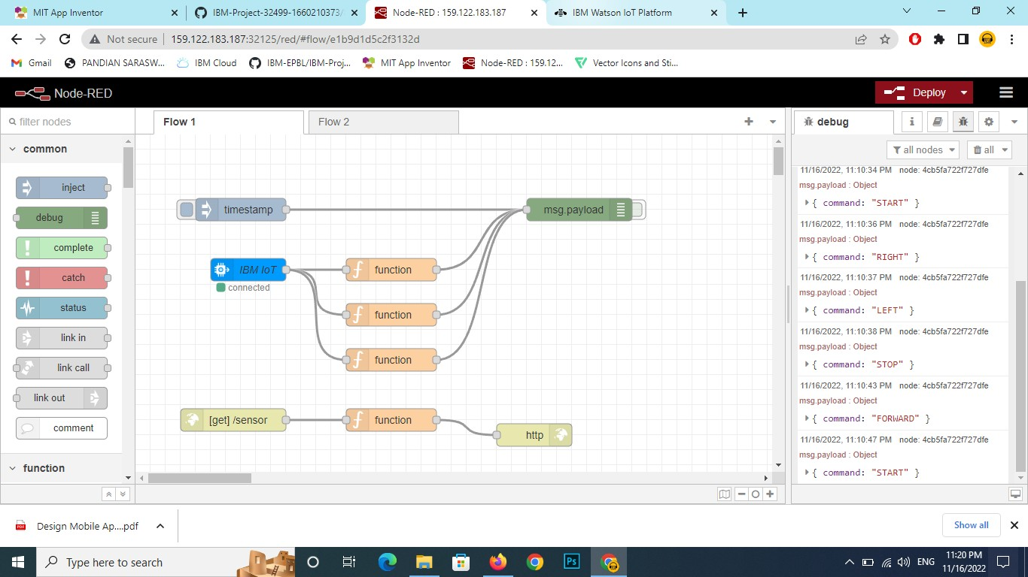

UI Nodes configuration:

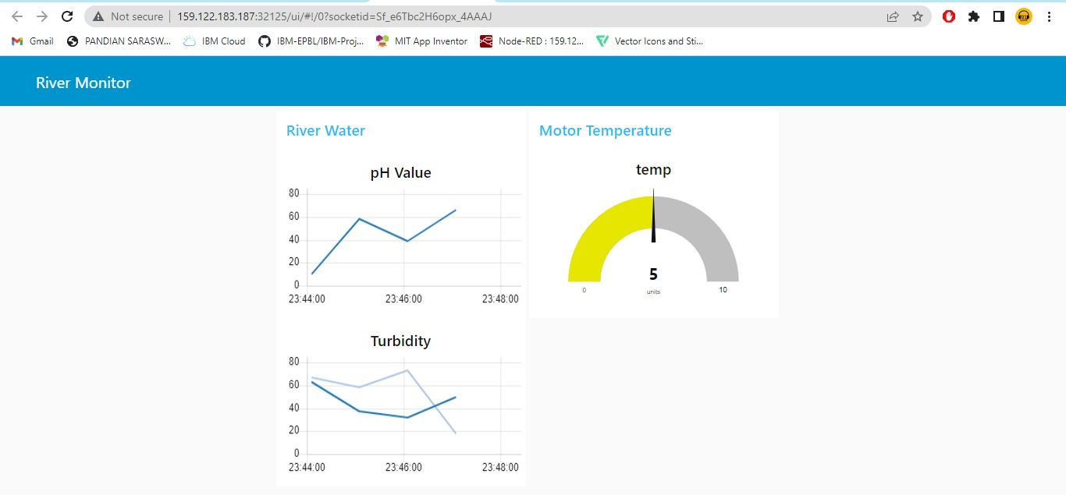

It is Backend of Our App:

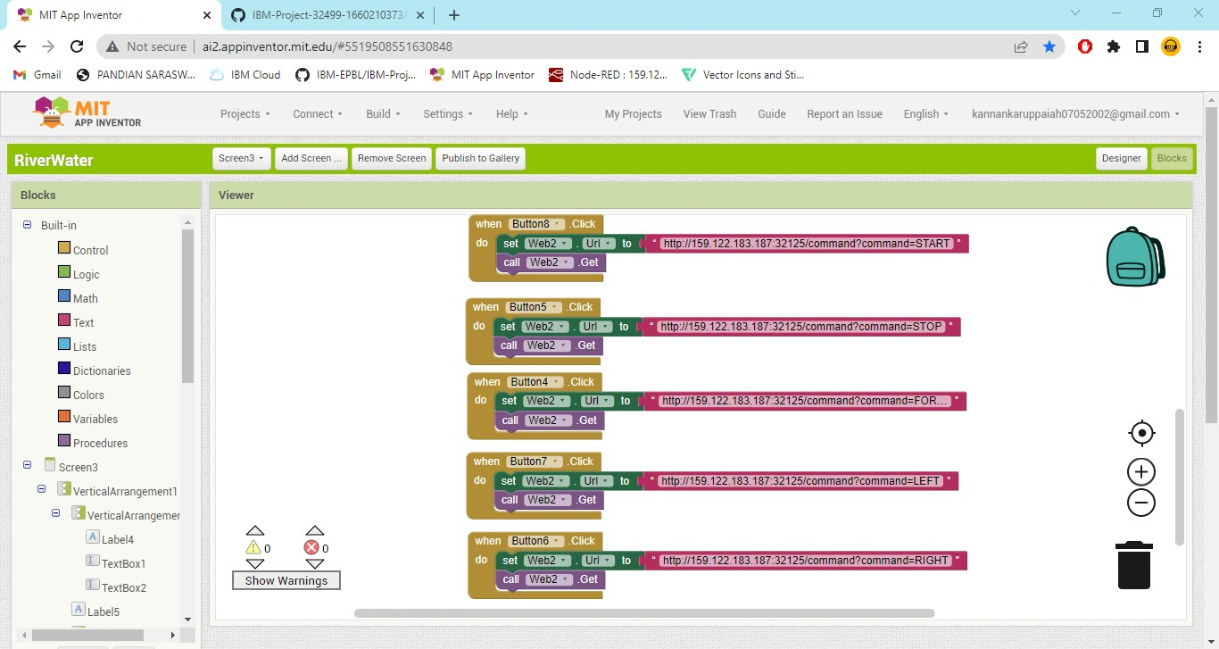

Controller Components: